3. Create a many to many ER table using ORM and perform CRUD operation.

* Created Customer, Order and Product on models.py to make many-many relations.
* Registered all the entities in admin.
* Apps and database was connected in settings.py
* Python manage.py makemigrations
* Python manage.py migrate.
* Tables were made on the Postgresql

Crud operation is performed.

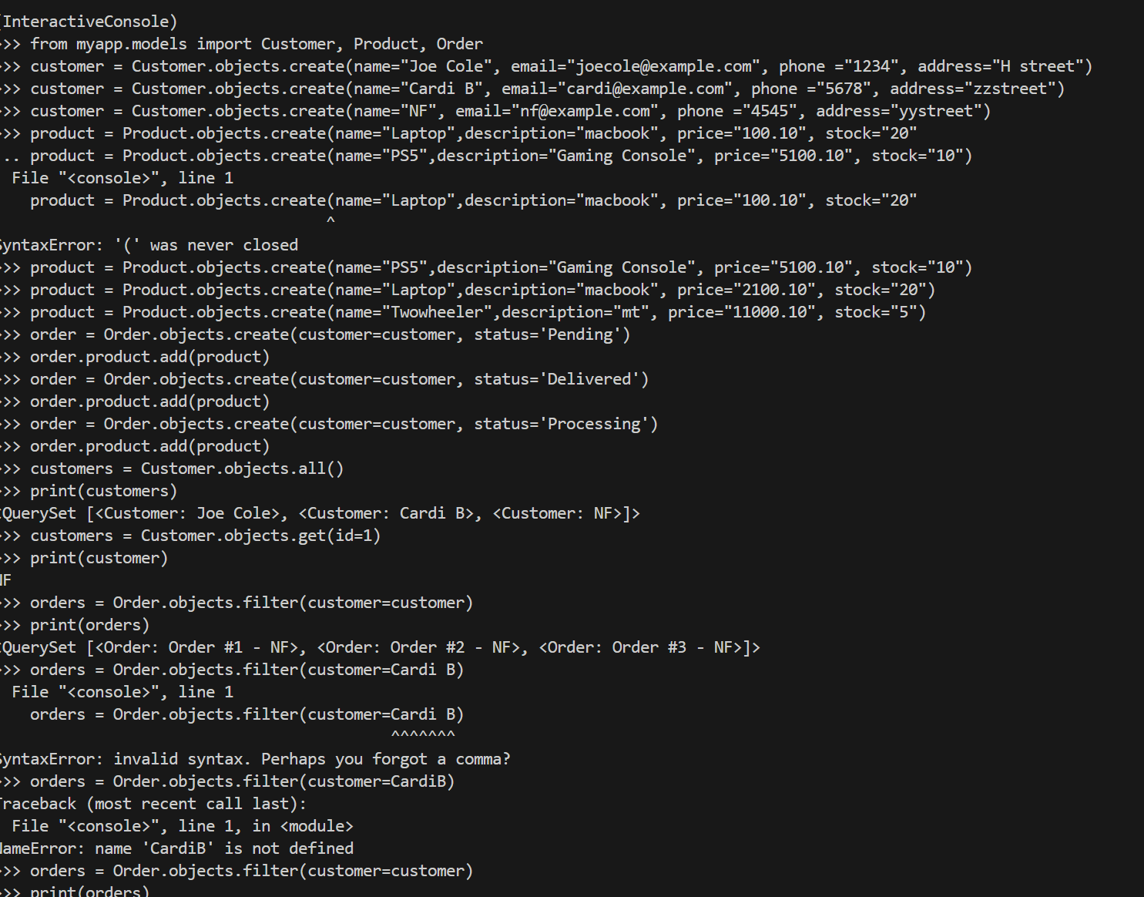

CRUD Operation. 